

**CSE488 (Section 1)**

**[Spring 2023]**

**Lab Assignment Submission Report**

**All Online MapReduce LAB**

**Submitted by:**

**Sazzad Hossen**

**ID: 2019-1-60-063**

**LAB 1**

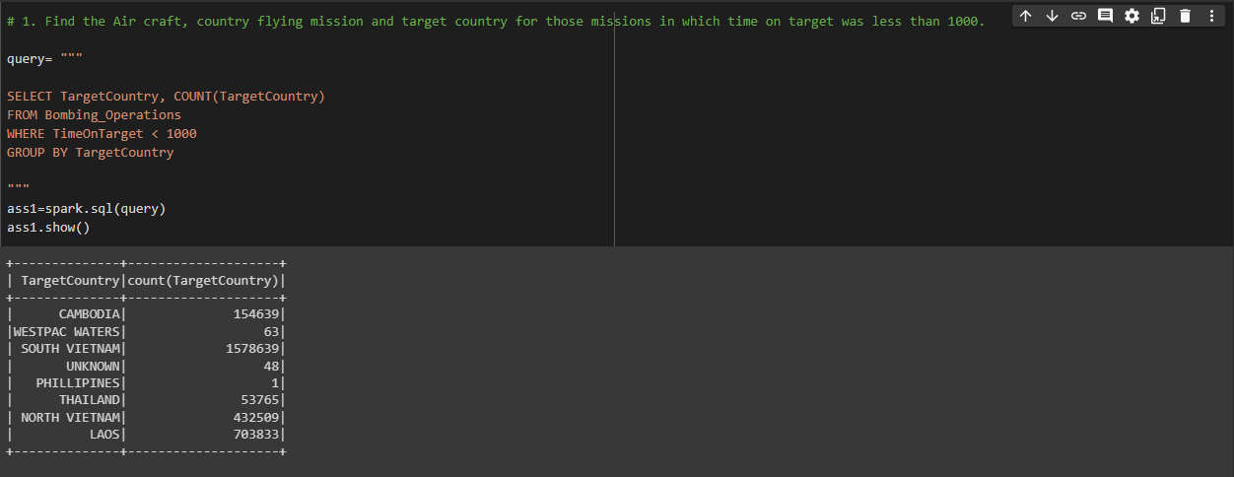

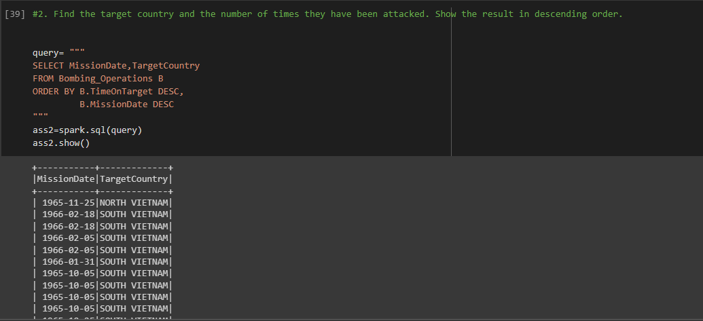

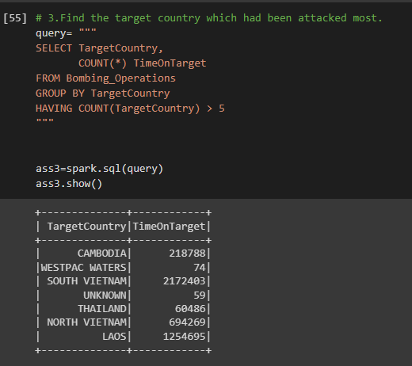

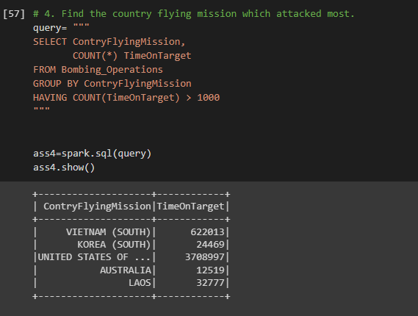

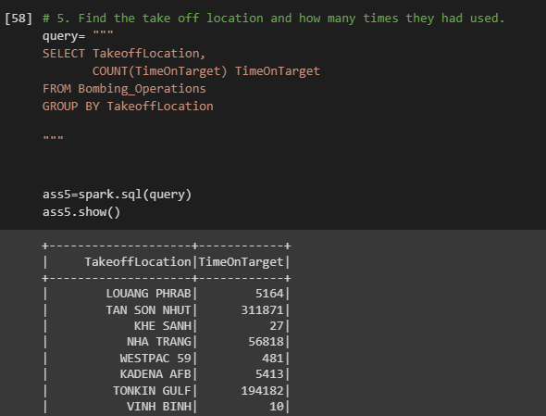

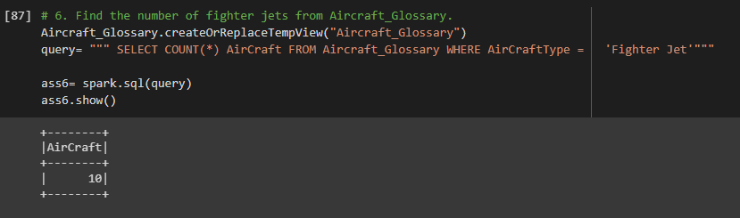

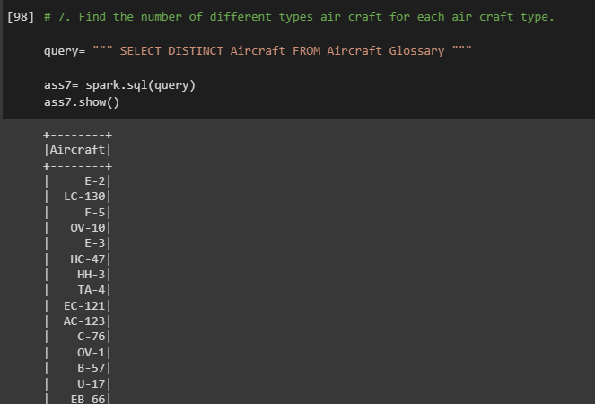

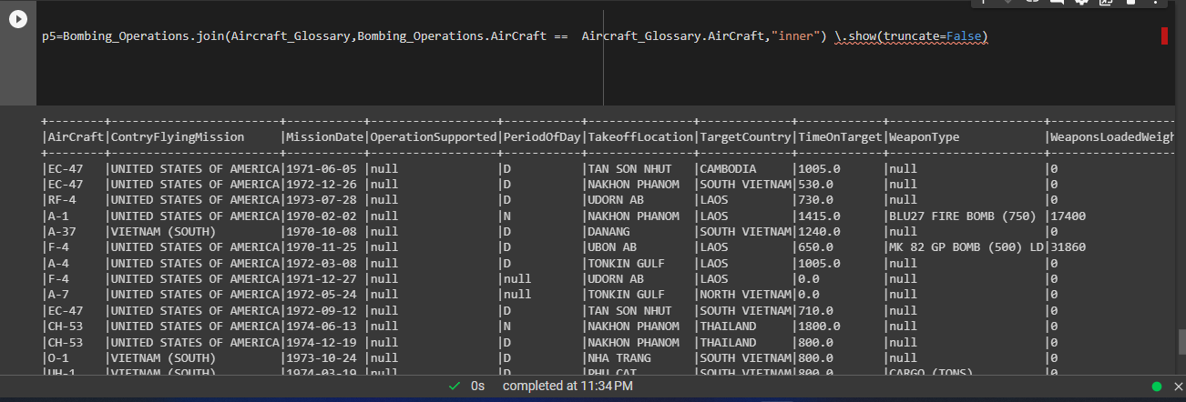

**LAB 3**

**Sum Calculator:**

**LAB 4**

**INPUT:**

**Output:**

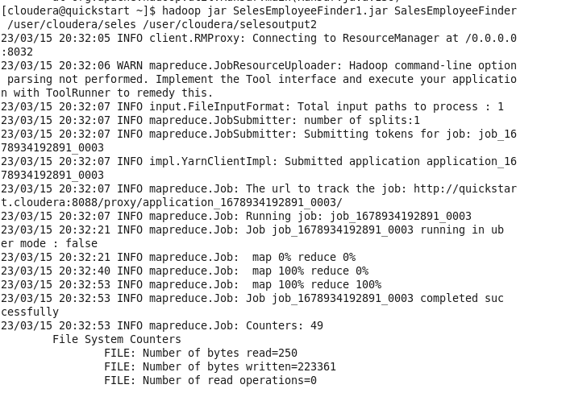

**LAB 5**

**JAVA FILE:**

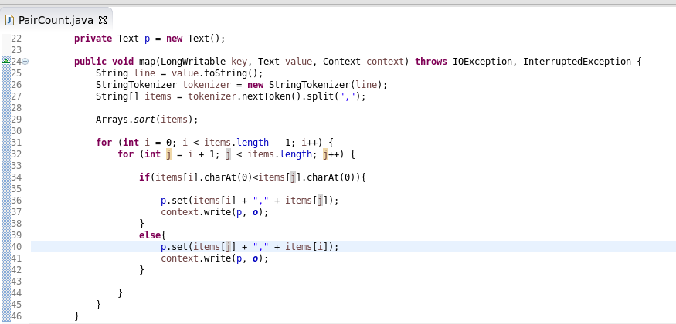

**JAR file Create “Pair Count”:**

**Dataset input in Hue Cloudera:**

**Run in Terminal:**

**Output:**

